# Introduction

For our research project we looked at the paper *The fate of the American dream: A first passage under resetting approach to income dynamics* by Petar Jolakoski et al. In their paper they attempt to calculate how long it would take an American worker to reach a certain level of income. This is relevant because the previous way of doing this used income transition matrices with aggregated probabilities. This is useful but only for quantiles of American workers(i.e. Bottom 10% of income made, top 10% of income made etc.). This model aims to take any income from a particular worker and predict how long it would take to reach a target income. Using this method could answer questions such as: What is the time it takes a minimum wage worker to reach a reasonable income? What percentage of workers are able to reach a good income during their life? How easy is it for workers to reach certain income targets?

Instead of previous approaches that use income transition matrices which use aggregate probabilities. The researchers modeled income dynamics using Geometric Brownian Motion with stochastic resetting (srGBM). To start our research project we focused on better understanding stochastic processes specifically srGBM which was used in the paper. The first steps in understanding srGBM was to code a simple version of Geometric Brownian Motion.



Here is a GBM path we simulated.

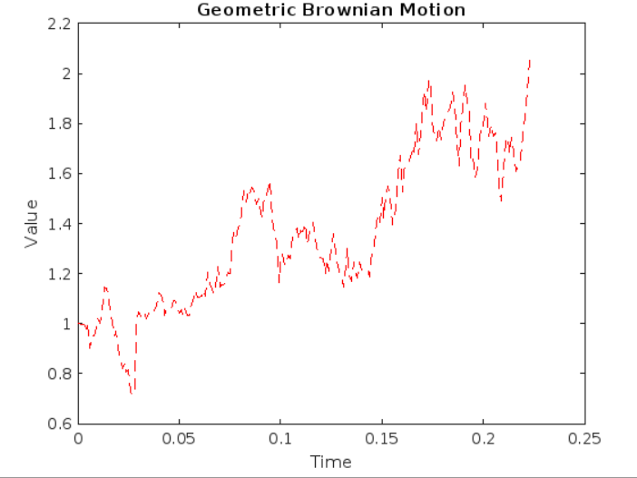

We then coded Geometric Brownian Motion with Stochastic Resetting implemented (srGBM). Below is the equation for srGBM.



This graph is a realization of srGBM with all parameters set to 1 and the resetting set to 25.

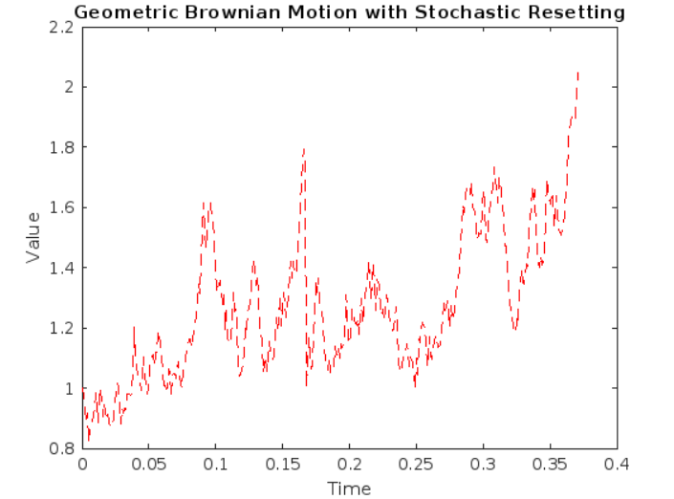

**First Passage Time**

Important to stochastic processes is the notion of First Passage Time. First Passage Time (FPT) is the time it takes for a random variable to reach a certain threshold or target value for the first time. In the context of income dynamics, the FPT is the time required for a single individual's income to reach a specific target income.

Mean First Passage Time (MFPT) is the expected value or average of the First Passage Times over an ensemble of random processes or a large number of trials. In the context of income dynamics, the MFPT estimates the expected time for a worker given certain parameters to improve their income level.

Once we had an implementation of srGBM. We began calculating Mean First Passage Times for various sets of simulations. We simulated “n” number of srGBM paths and stored each FPT and then took the average of FPTs. In the paper on page 3 these equations are given for the Mean First Passage time.

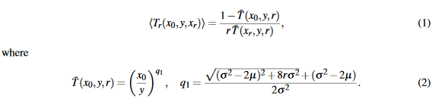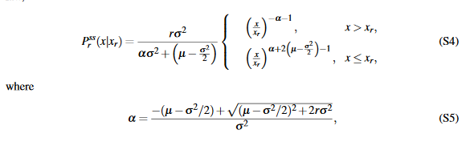

To check that our code was working we compared our estimated MFPT with the analytical MFPT calculated with the equations. We were able to confirm that our estimated MFPT was close to the actual MFPT.

We also verified our code by comparing the PDf generated by our income simulations with the stationary srGBM PDF given by this equation

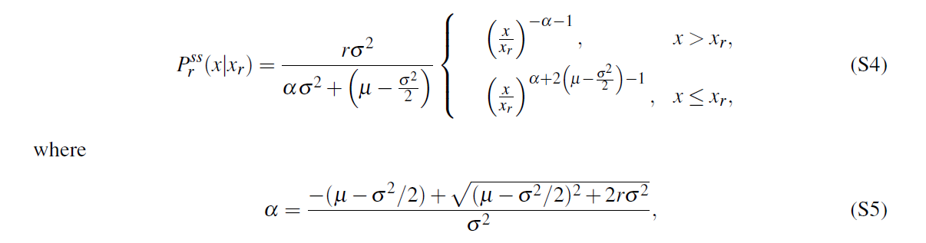

This PDF describes the probability that the income is at any point x after a long time. Here is the graph of the stationary PDF

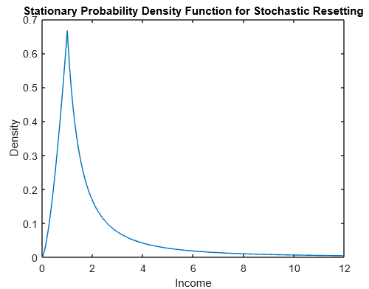

This PDF equation describes a stationary distribution with resetting (r>0) at time 𝘵→infinity.

By simulating the path of many different incomes over an extended time period using the aforementioned srGBM function, we come up with a probability distribution very similar to the predicted PDF. Our result is shown in red. The resultling histogram distribution was able to match closely with the suggested equation.

# 

# **Estimating Parameters**

The researchers in the original paper were able to estimate the parameters mu and sigma needed for the srGBM equation, using real world data. They used the unemployment rate and the overall percentage of wealth held by the Top 1 percent of earners. They gathered the data from the years 1978 to 2015.

We sourced our data from the same source and were able to collect quarterly data between the years 1990 to 2021. Below is a graph of the data we collected.

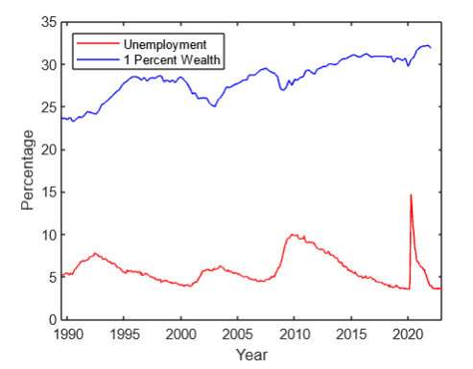

Using this data we attempted to follow the steps for the empirical estimation of srGBM parameters. The method for empirical estimation of srGBM parameters involves estimating the model parameters, such as the drift parameter (μ), noise amplitude (σ), and resetting rate (r), based on the observed data of income distribution. In this case, the shares of income owned by the top 1% in the US income distribution are used as our output.

According to the steps in the paper we let r(t) be the unemployment rate per year. We then used the function below of the income percentage using random mu and sigma values to estimate the income value x99. Where X99 is the number given when the PDF function is equal to .99 or the income level for 99th percentile of income.

$\int_{0}^{X99}{}$ $PDF(x)dx$ = .99

Using the x99 we found. We then attempted to get the output of this equation for the income share

$\int_{X99}^{∞}{}xPDF(x)dx / \int_{0}^{∞}{}xPDF(x)dx$

to match the income share of the top 1% that we pulled from the St. Louis Federal Reserve. Our plan is to write a numerical method which can find a mu and sigma which leads to an output that is closest to the real world income share.

# Conclusion: Next Steps

Unfortunately we were not able to find the parameters for mu and sigma. This would have allowed us to use the unemployment rate and top 1% income share data from countries outside of the U.S. and for individual states to calculate MFPT. Our plan was to use this with statistics from different states' income and/or different countries. However, troubleshooting code became a problem and so did following the steps of the paper. It wasn’t always clear what the author’s of the paper did to get their results. We were able to figure out how the mu and sigma is estimated but did not have time to implement it.

Resources used:

Jolakoski et al. -2022- The fate of the American dream A first passage under resetting approach to income dynamics.pdf

Higham- An Algorithm Introduction to Numerical Simulation.pdf

Stojkoski et al. -2020- Generalised geometric Brownian motion Theory. Pdf

<https://fred.stlouisfed.org/series/WFRBST01134> (Top 1% wealth)

<https://fred.stlouisfed.org/series/UNRATE> (unemployment rate)